Chapter 11
Fungi as Vectors:
Fungi Can Vector Plant Viruses, Viroids, and Bacteria

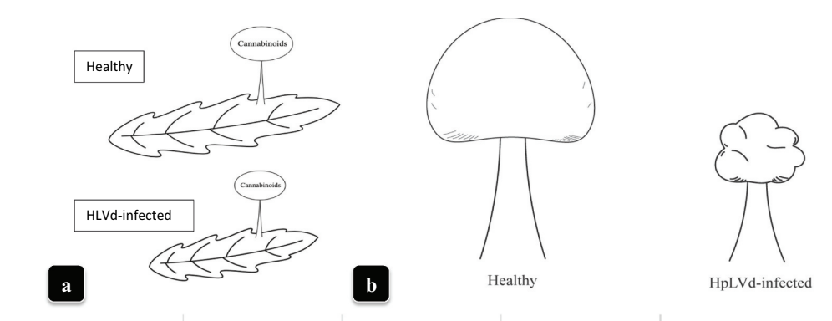
Figure 1. Effect of virus on Cannabis leaves (A) and trichomes (B). (Punja et al 2023)

Cannabis plants can serve as hosts to a variety of microorganisms, including fungi and bacteria. Additionally, these microbial symbionts (or pathogens) can themselves be infected by even smaller organisms, such as viruses and viroids. This chapter will explore how fungi can influence plant growth and performance, depending on whether the fungus is infected with other organisms. Research has indicated that certain fungi can act as vectors, facilitating the spread of viruses from one plant to another.
Viruses and viroids pose an emerging threat to farmers cultivating various crops. While many viruses exist without causing obvious harm to the host plant or may even be beneficial, their effects can sometimes lead to devastating diseases in plants. Viruses consist of DNA or RNA enclosed in a protein coat, whereas viroids are even smaller, containing low-molecular weight RNA without the protein coat (Fig 1). Both viruses and viroids rely on the cellular machinery of their host plants in order to replicate.
Table 11.1. Known viral, viroid, and phytoplasma diseases putatively affecting Cannabis. Phytoplasma diseases are obligate bacterial parasites of plants vectored by insects or arthropods.

Viruses | Viroid | Phytoplasma
- Beet curly top virus (BCTV)  - Alfalfa mosaic virus (AMV)  - Arabis mosaic virus (ArMV)  - Cucumber mosaic virus (CMV)  - Tobacco ringspot virus (TRSV)  - Tomato ringspot virus (ToRSV)  - Tobacco streak virus (TSV)  - Tomato mosaic virus (ToMV) | - Hop Latent Viroid (HLVd) | - Candidatus phytoplasma trifolii

Fungi naturally acquire viruses and viroids in a manner similar to plants. Many plant and fungal viruses do not persist outside of their hosts for long, even with protective capsids. Unencapsulated RNA and DNA are typically quickly degraded or destroyed in the external environment. However, viroids, in particular, have shown an impressive ability to persist without a protective protein capsule. They can survive for days on surfaces, weeks in water, years in dried plant material, and even decades within seeds (Singh et al., 1977; Singh et al., 1991; Mackie et al., 2015). The unique tertiary structure formed by viroid RNA, which loops back upon itself, is likely responsible for its remarkable resilience to degradation and plays a role in its interactions with host proteins (Hull, 2014).
Even when infectious viroids and viruses are present in the environment, plants have protective structures that usually exclude them. In order to enter an uninjured plant, viruses and viroids may first infect an organism, such as a fungus, which can then serve as a vector to transfer the infectious agent to the plant. Fungi acquire nutrients by engulfing material through endocytosis (Barata-Antunes et al., 2021). This engulfed material may include infectious agents, which are able to evade digestion.
Fungi were first confirmed to become infected with plant viroids—where active viroid replication occurs—when avocado sunblotch viroid was shown to infect and replicate in Saccharomyces cerevisiae (baker's yeast) (Delan-Forino et al., 2011). More recently, it has been demonstrated that various plant-interacting fungi are capable of hosting plant viroids (Friday et al., 2017; Wei et al., 2019).
Andika et al. experimentally confirmed that fungi can act as vectors for plant pathogenic viruses, transferring these viruses into previously uninfected plants (Andika et al., 2017). A notable model system for this interaction involves the cucumber mosaic virus (CMV), Rhizoctonia solani, and Solanum lycopersicum (tomatoes). This is an especially relevant system as both CMV and R. solani are plant pathogens with broad host ranges (including cannabis), making them significant for most farmers and gardeners. Rhizoctonia solani is known for causing damping off and root rots.
There is no reason to believe that only pathogenic fungi can transmit viruses in this way. Although the documented cases thus far have involved experimentally infected fungi, and natural viroid infections of fungi have not yet been identified, it is increasingly accepted that such infections likely occur in nature (Sun and Hadidi, 2022). The likelihood of a virus or viroid being vectored into a plant by a fungus depends not only on the host-virus/viroid interaction but also on the microbiome and environmental context in which the interaction occurs. For example, Bain et al. showed that Cryphonectria hypovirus 1 (CHV1) could infect a plant leaf but could not move systemically through the plant unless the host was co-infected with tobacco mosaic virus (TMV). The viroid relied on TMV movement proteins to move from cell to cell. Interestingly, this same group demonstrated that the plant-pathogenic fungus Fusarium graminearum was more susceptible to TMV infection when co-infected with CHV1 due to CHV1's disruption of the fungal host’s RNA-silencing-based immune responses.
It is likely that plant mutualistic fungi are also capable of hosting and transmitting harmful plant viruses in a similar manner to pathogenic fungi. Additionally, bacteria and archaea may internalize and transfer plant and fungal viruses/viroids within the environment to new hosts. Bacteria and archaea have cellular machinery that allows them to internalize exogenous DNA, which can become an important source of genetic novelty if incorporated into their genome (Wagner et al., 2017).
Fungi can also transfer viruses among each other through anastomosis (hyphal fusion) of compatible fungi. When hyphae fuse, they are able to transfer cytoplasm and much of its contents, including viruses, between the fungi. In the case of ascomycetes, even nuclei can flow freely between the fungi. If the fungi are compatible, they will transfer viruses contained in the cytoplasm into the newly fused individual. Sometimes, non-compatible fungi may form transient bridges, posing a viral transfer risk even if anastomosis is not stable.
Fungi represent potential reservoirs of plant viruses. It is likely that both mutualistic and pathogenic fungi have complex relationships with viruses—ranging from harmful to beneficial—that can infect plants. This “harmful or helpful” relationship can vary depending on whether the virus is infecting the fungus or the plant, and under different environmental conditions.
For cultivators concerned with viruses, one approach to limiting the introduction of viruses is to select germplasm that has been screened for viruses and is known to be tolerant of infection. Additionally, tools—especially blades—should be sterilized between plants to limit the movement of viruses, thus preventing their spread on the farm (Miotti et al., 2023). It is also important to manage insect pests both indoors and outdoors, creating a competitive environment that reduces their impact and population, as insects are often vectors of viruses. This strategy should include recognizing that viruses, viroids, and even bacteria can survive and maintain themselves within alternative host organisms, including fungi, even in otherwise unfavorable environments. Beyond strong preventative hygiene practices, growers need not be overly concerned about viruses and viroids unless they are experiencing problems with these agents.
Table 11. 2 Tool sterilization solutions effective at eliminating most plant viroids. Concentration of sterilizing agent and contact time both affect sterilization efficacy (Kai-Shu Ling, 2017).
 | Time | Efficacy
10-20% household bleach | 5-10 minutes | Very effective but corrosive on tools
2% Virkon | Disinfect until visibly clean | Very effective
20% Dry Skim Milk | 10-20 minutes | Partially effective

When experiencing a viral problem, one option to consider is performing a 'farm reset,' which involves pasteurizing or sterilizing the soil or media. This process is aimed at removing a significant portion of the living fungi that could potentially host plant viruses. Afterward, amending the soil with known disease-free, living soil or compost can help inoculate it with pathogen-free soil microbes. A diverse microbial population in the soil will help limit the spread of viruses by spatially separating the range of potential host organisms, which may interact in a way that could lead to pathogen transfer—such as anastomosis of compatible vegetative fungal individuals.
The symptoms of viral infections in plants can vary widely, from severe symptoms to being completely asymptomatic. Because of this variability, it is crucial to have sophisticated identification tools available to detect infected plants. Techniques like ELISA (Enzyme-Linked Immunosorbent Assay), DNA/RNA hybridization, PCR (Polymerase Chain Reaction), and gel electrophoresis are commonly used to identify viruses and viroids in plants. These methods can provide highly sensitive and accurate results, allowing growers to detect even low levels of infection that might otherwise go unnoticed.

In summary:

- Viruses and viroids can pose a serious threat to Cannabis cultivators everywhere
- Fungi can act as vectors transmitting viruses or other diseases to plants

